**Machine Profile**

**Series – Confidence Series**

**Product –** High Speed Automatic Folder Gluer

**Model –** RI-EZEFOLD-580AC

**Warranty –** 2 Years

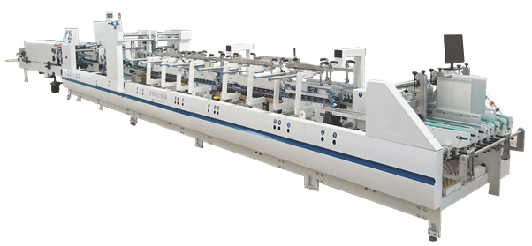

Please note that the picture is for **ILLUSTRATION ONLY** and may vary from the equipment offered.

**Machine Features:**

1. 2 No’s of Suction Belts at Feeder Section.
2. Independent AC motor for Feeder Section.
3. Standard Accessories for A & B type Straight Line Cartons.
4. Advanced Gluing Tank with Unique Scrapper Device with Micro-Metric adjustment for precise gluing.
5. Glue Tank Designed for Easy to Clean.
6. Standard Glue Tank on Left Side.
7. Batch Counter equipped with Electronic Sensor.
8. Conveyor Pressure can be adjusted pneumatically.
9. Maximum Feeding width: 580 mm.
10. Can work with Cardboard 220 – 600 GSM, Corrugated Board E Flute.
11. Power Required: 18kW
12. Speed: **350 meters/min**
13. Standard 2 Years Warranty

**Configuration:**

|  |  |  |  |
| --- | --- | --- | --- |
| **S. No.** | **Features** | **Include** | **Worth INR** |
| 1 | Suction Feeder Belt | Y |  |
| 2 | Pneumatic Blank Vibrator | Y |  |
| 3 | Pre-Folding Accessories for Side Pasting A Type Carton | Y |  |
| 4 | Pre-Folding Accessories for Side Pasting B Type Carton | Y |  |
| 5 | Both Side Std. Glue Wheel 3 mm | Y |  |
| 6 | Extra Pressing Belt | Y |  |
| 7 | Optional Blank Aligner Section | N | ₹ 3,75,000 |
| 8 | Optional UV Grinder to Scratch the UV Varnish from Glue Flap | N | ₹ 1,25,000 |
| 9 | Optional Plasma with Single Gun -750 VA | N | ₹ 1,50,000 |
| 10 | Optional Mini Box Folding Device (80X60mm, Straight Line Carton Can Do) | N | ₹ 78,000 |
| 11 | Optional Tube-Light Carton Attachment | N | ₹ 90,000 |
| 12 | Optional Braille, 5 Lines Improved Method of Female Braille Tool | N | ₹ 38,00,000 |
| 13 | Optional Double Sheet Detector | N | ₹ 2,50,000 |
| 14 | Optional Conveyor Ejector Device | N | ₹ 3,25,000 |
| 15 | Optional Semi-Automatic Collecting Table | N | ₹ 5,90,000 |
| 16 | Optional 3 Years Additional Warranty | N | 100,000/Year |

**Feeder Section:**

1. 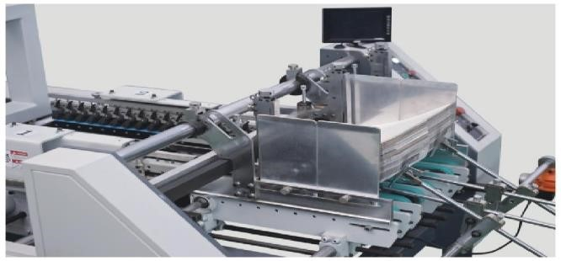5 Feeding Belts along with 2 Suction Belts.
2. Each Feeder Belt can be Adjusted Independently.
3. Equipped with Adjustable Feeding Knives -2 Pcs.
4. Equipped with Pneumatic Vibrator- 1 Pcs.
5. Suction System - 1 Set
6. Motorized Friction Feeder with Independent AC Motor.

**Aligner Section:(Optional)**

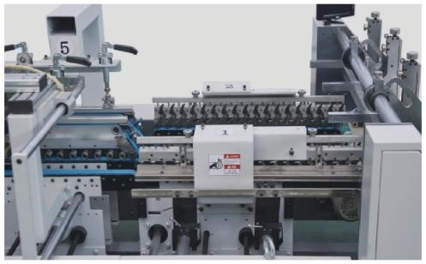

1. Aligner Guides the Box to A Parallel Handrail That Allows a Perfect Box Alignment.
2. Can Register to Left or Right Depending on Box.
3. It helps to Minimize the Waste and Reduce Machine Stoppage Due to Error in Carton Which Comes from Feeder.
4. This Section Available as An Option.

**Pre-Folding Section:**

1. 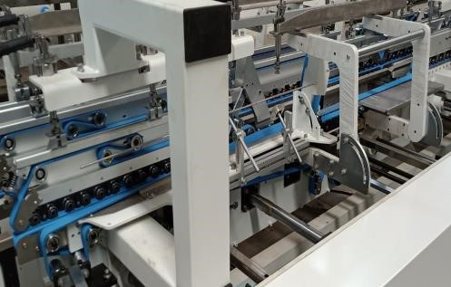1st Crease Pre-Folding 180 Degrees
2. 3rd Crease Pre-Folding 165 Degrees
3. Equipped with Nitta Folding Belts
4. Standard Accessories for B-Type Folding Carton
5. Both **Upper & Lower** Carrier can be Removed

While running Small Size Carton.

**Braille:(Optional)**

The BRAILLE is the Solution for The Rotary Embossing on The Boxes in Folder Gluer. The Embossing Realized in The Folder Gluer allows Great Benefits, Including:

1. 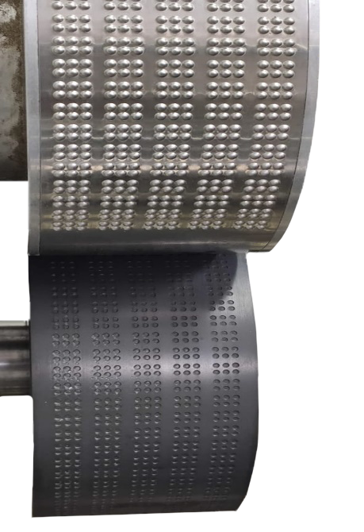The Uniform Pressure on Every Score (“dot”) Punched without any delay.
2. The Possibility to Emboss without Problems also Possible to do at Edge of the Creasing.
3. The Possibility to Vary the Embossing Pressure Depending on Grammage and on Cardboard Fiber or On the Needs of the Final Consumer.
4. Braille is the Most Versatile Braille Rotary Solution Patented on the Market to Realize the Embossing of Pharmaceutical Boxes in 4 and 5 lines of Braille with Single or Double Layer in Folder Gluer.
5. The Braille Molds are Made by CNC Machine.

**Braille Specifications:**

1. Unique Design of Female and Male Braille Cylinder to avoid High Maintenance Cost.
2. Braille Precision – 0.03
3. Finished Dot Height – Max. 0.23mm
4. Finished Dot Diameter – 1.8 mm
5. Front Position Precision – +/- 1.5 mm.
6. The maximum Braille Speed – 200m/min

**Glue System:**

1. 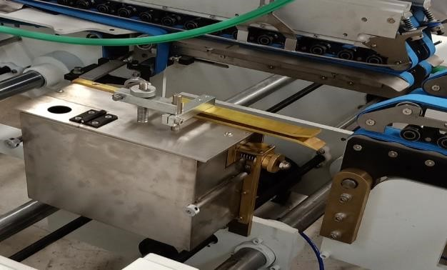Equipped with Advanced Left Side Gluing Tank with Unique Scrapper Device with Micro-Metric Adjustment for Precise Gluing.
2. Easy to Remove All Equipment for Quick Cleaning.
3. Standard 3 mm Glue Disc (Optional Glue Disc width 4, 5, 6, 8,10mm).

**Folding & Closing Section:**

1. 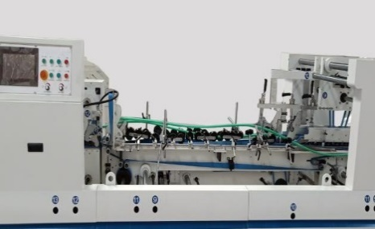Main Motor Controlled by Frequency Speed Variation.
2. Smooth and Accurate Folding of 2nd & 4th Crease.
3. Two Set of Upper and Lower Carrier, they are Drive, Middle and Control Side of Machine.
4. Left and Right Outward Folding Belts Speed can be Micro Adjusted to Increase Folding Accuracy.
5. Equipped with Branded Folding Belts.

**Trombone Section:**

1. Upper & Lower Drive Mechanism for Box Length Adjustment.
2. Equipped with Automatic Belt Tension Adjusting System.
3. Upper Arm Set can be Adjusted Backward and Forward to Ensure a Continuous and Automatic Box Collection Mechanism.
4. Equipped with a Control Screen for Operating the Machine.
5. Single and Easy Operation for Upper, Down Expansion Adjustment, Left or Right Twin Board Moveable for Piling.
6. Batch Counter Equipped with Electronic Sensor.

**Delivery Section:**

1. 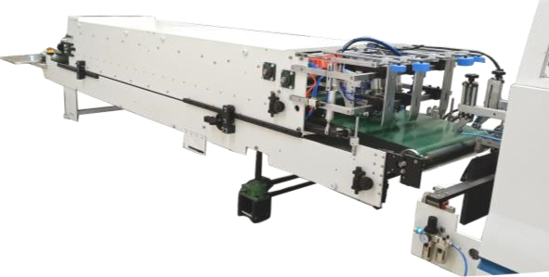Independent Motor for Delivery Section for Synchronization of Machine Speed.
2. Upper Conveyor can be moved Forward and Backward, Depending on the Box Length.
3. Conveyor Pressure can be Adjusted Pneumatically.
4. With New Structure, it can run Automatically with Accountable Sensor Pile the Boxes for High Efficiency.

**Box Dimensions:**



With Mini-Folding Device can run Minimum 80 X 60 mm, Open Blank.

Machine Speed Depends on Quality & Calliper Thickness of Material.

**Collecting Table (Optional):**

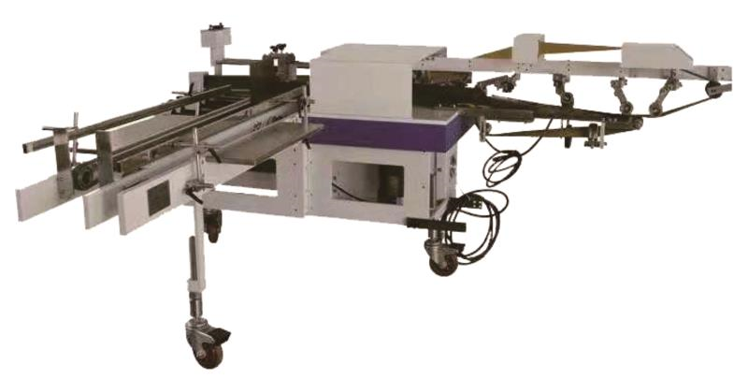

RI-SH450 is Collecting Table to Make the Packaging Easier. Its Operation is Simple and Humanized Design Can Use for Almost All Types of Carton Packaging Which Allows to Collect the Boxes in Batches After the Press Section at a Speed of 400 Meters/Min, Which Greatly Improves the Work Efficiency, And Reduces the Labour Intensity.

|  |  |
| --- | --- |
| Max. Open Blank Size | 440 X 500 mm |
| Min. Open Blank Size | 50 X 100 mm |
| Weight | 600 Kgs |
| Voltage | 220V/50HZ |
| Power Required | 2 kw |
| Machine Dimension | 2800 X 2300 mm |

**“Really Small Investment, Big Gains”**

The Collecting Table Costs a Little Money, But It Can Maximize the Efficiency of The High-Priced High-Speed Box Machine, At the Same Time, The Number of Workers in The Process of Receiving Boxes Is Greatly Reduced ~Two People Can Complete the Work of The Original Six People! Half A Year's Artificial Wages Will Be Able to Recover the Investment!